Summer camp 2022

STEAM camps



Entering

2nd – 6th Grade

**Max enrollment for all STEAM camps are noted**

Entering

1st– 5th Grade

Entering

6th – 12th Grade

June 13th – 17th

June 20th – 24th

June 27th – July 1st

July 5th – 8th

July 11th – 15th

July 18th – 22nd

July 25th – 29th

August 1st – 5th

August 8th – 12th

August 15th – 19th

S.T.E.A.M. V.2 60 max.  
Storybook Engineers 60 max.  
Funbots 60 max.  
The Great Escape 60 max.  
What does a Scientist Do? 60 max.   
GenArt 60 max.  
Whodunnit? 60 max.  
The Human Body 60 max.   
The Interstellar Traveler 60 max.  
All Star: Go Play 60 max.

Breaking Bread 20 max.  
Animagin: Craft your world 20 max.  
SSS: A Barracuda Taco Dodger 20 max.  
Empira Imaginata 20 max.  
Escape Plan 20 max.  
Flat Earth Society 20 max.  
Planet X 20 max.  
The Devs 10 max.  
The Devs 10 max.  
Fantasy Feast 20 max.

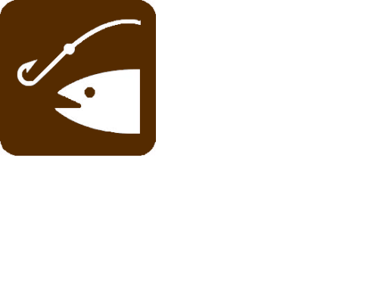

### Sports camps

**Max enrollment for all sports camps is 40 unless otherwise noted**

Entering

Tennis 20 max.  
Martial Arts   
Volleyball  
Cheer Camp  
Golf 20 max.  
Basketball   
Bike Safety 20 max.  
Lacrosse 30 max.   
Summer Vibes   
Crossfit **5th & 6th Grade Only** 20 max.

June 13th – 17th

June 20th – 24th

June 27th – July 1st

July 5th – 8th

July 11th – 15th

July 18th – 22nd

July 25th – 29th

August 1st – 5th

August 8th – 12th

August 15th – 19th

3rd – 6th Grade

**closed weeks:**

June 6th-10th &

Aug 22nd-26th

[](http://www.google.com/imgres?q=grass+clipart&start=178&hl=en&biw=1024&bih=571&tbm=isch&tbnid=z1gG7v82x3rw-M:&imgrefurl=http://www.carcabin.com/grass-border-4jpg/gardencare-uk.co.uk*images*Grass_Border_4.jpg/&docid=LS_cQOB19a3ltM&imgurl=http://gardencare-uk.co.uk/images/Grass_Border_4.jpg&w=3000&h=600&ei=h8pAUZKXNMO_rQH0zIHIAg&zoom=1&iact=hc&vpx=474&vpy=99&dur=1062&hovh=100&hovw=503&tx=340&ty=61&page=9&tbnh=48&tbnw=239&ndsp=25&ved=1t:429,r:83,s:100,i:253)

**1144 NE Cedar St. Roseburg, OR 97470 Phone: (541) 440-9505 Website: www.bgcuv.org**

GREAT  START HERE.

**Club opens at 7:30, camps start at 8:30 and end at 11:30.**

Lunch served 12:00-1:30; USDA meals are free for children 1-18 regardless of membership status. Children 6 and younger must be supervised at all times. This institution is an equal opportunity provider.

**The following scales are based off of household size and income, and you must provide proof at time of registration.**

**Scale A $40 per week   
Scale B $60 per week**

**Scale C $80 per week  
Scale D $100 per week**

SPORTS CAMP

Our Sports Camps are designed to get participants engaged in heart-racing games that will leave them full of life. Participants will learn innumerable social, mental, and of course physical skills that will benefit them for years to come! All participants are required to participate in the day’s activities or parents will need to pick up their youth.

Our Sports Camps are designed to get participants engaged in heart-racing games that will leave them full of life. Participants will learn innumerable social, mental, and of course physical skills that will benefit them for years to come! All participants are required to participate in the day’s activities.

STEAM CAMP

If you’re looking to explore some hands-on, thought provoking, and downright fun activities then our STEAM (Science, Technology, Engineering, Arts, and Math) Camps will draw you in like a black hole! STEAM Camp participants will be having so much fun they won’t even realize they’re learning!